**VINAYA SV**

**727721EUIT178**

**CODING CONTEST-2**

**SOURCE CODE:**

package com.Q.Question1;

import org.testng.annotations.Test;

import io.github.bonigarcia.wdm.WebDriverManager;

import org.testng.annotations.BeforeMethod;

import org.openqa.selenium.By;

import org.openqa.selenium.WebDriver;

import org.openqa.selenium.chrome.ChromeDriver;

import org.openqa.selenium.chrome.ChromeOptions;

import org.testng.Assert;

import org.testng.annotations.AfterMethod;

public class Part {

WebDriver driver;

*@Test*

public void PartA() {

ChromeOptions co=new ChromeOptions();

co.addArguments("--remote-allow-origins=*");

WebDriverManager.*chromedriver*().setup();

driver=new ChromeDriver(co);

driver.navigate().to("https://www.yatra.com/hotels");

driver.manage().window().maximize();

driver.findElement(By.*xpath*("//a[@id=\"booking_engine_flights\"]")).click();

driver.findElement(By.*xpath*("//a[@title=\"Round Trip\"]")).click();

}

*@Test*

public void PartB() throws InterruptedException {

driver.findElement(By.*xpath*("//input[@id=\"BE_flight_origin_city\"]")).click();

Thread.*sleep*(3000);

driver.findElement(By.*xpath*("//div[@class=\"viewport\"]/div/div/li[5]")).click();

Thread.*sleep*(5000);

driver.findElement(By.*xpath*("//input[@id=\"BE_flight_arrival_city\"]")).click();

Thread.*sleep*(3000);

driver.findElement(By.*xpath*("//div[@class=\"viewport\"]/div/div/li[2]")).click();

Thread.*sleep*(3000);

driver.findElement(By.*xpath*("//input[@id=\"BE_flight_origin_date\"]")).click();

Thread.*sleep*(3000);

driver.findElement(By.*xpath*("//input[@id=\"BE_flight_origin_date\"]")).click();

driver.findElement(By.*xpath*("//td[@data-date=\"23/04/2023\"]")).click();

Thread.*sleep*(3000);

driver.findElement(By.*xpath*("//td[@data-date=\"29/04/2023\"]")).click();

Thread.*sleep*(3000);

driver.findElement(By.*xpath*("//span[@class=\"txt-ellipses flight_passengerBox travellerPaxBox\"]")).click();

driver.findElement(By.*xpath*("//div[@class=\"iePasenger dflex\"]/div[1]/div[1]/div/span[@class=\"ddSpinnerPlus\"]")).click();

driver.findElement(By.*xpath*("//div[@id=\"specialFareContainer\"]")).click();

Thread.*sleep*(3000);

driver.findElement(By.*xpath*("//input[@id=\"BE_flight_flsearch_btn\"]")).click();

Assert.*assertEquals*(driver.findElement(By.*xpath*("/html/body/h1")).getText(),"Access Denied");

}

}

**CONSOLE:**

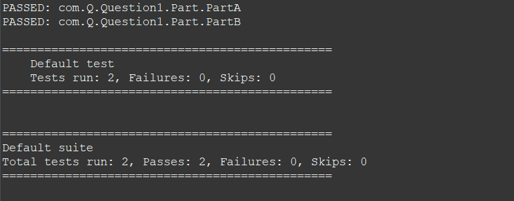

**EMAILABLE REPORT:**

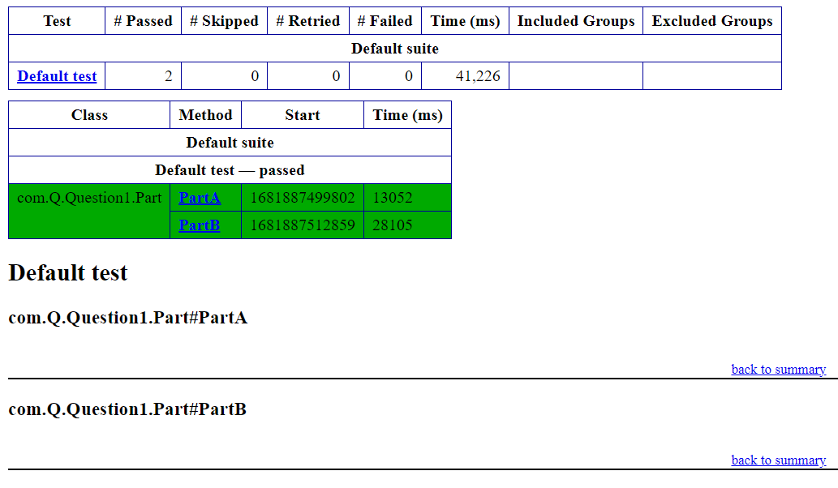

**FINAL OUTPUT:**

